Q7. Conduct a simulated phishing attack in a wide area network (WAN)
environment using any suitable tool to demonstrate potential risks, specifically
focusing on accessing webcams. Provide a detailed account of the steps you took
during the simulation.
Additionally, explain effective strategies for educating and raising awareness
among employees about safeguarding against such types of phishing attacks.

1. Git clone camphish from github: git clone https://github.com/techchipnet/CamPhish
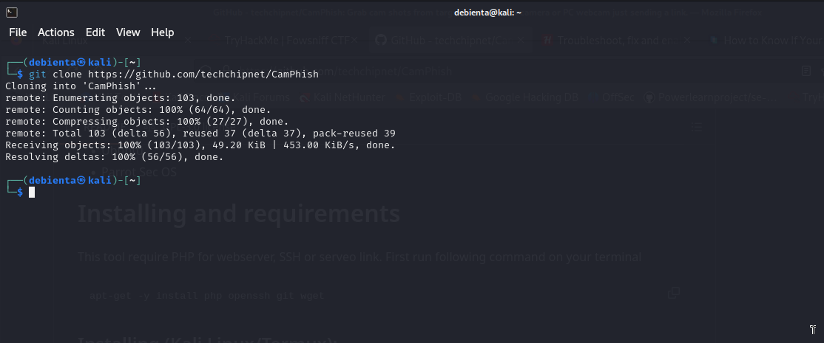
Change your directory to camphish: cd CamPhish
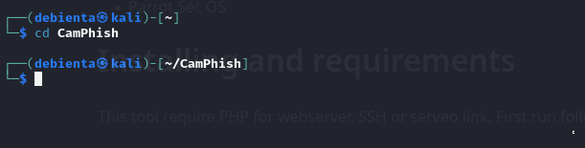
Run the bash file of camphish: bash camphish.sh
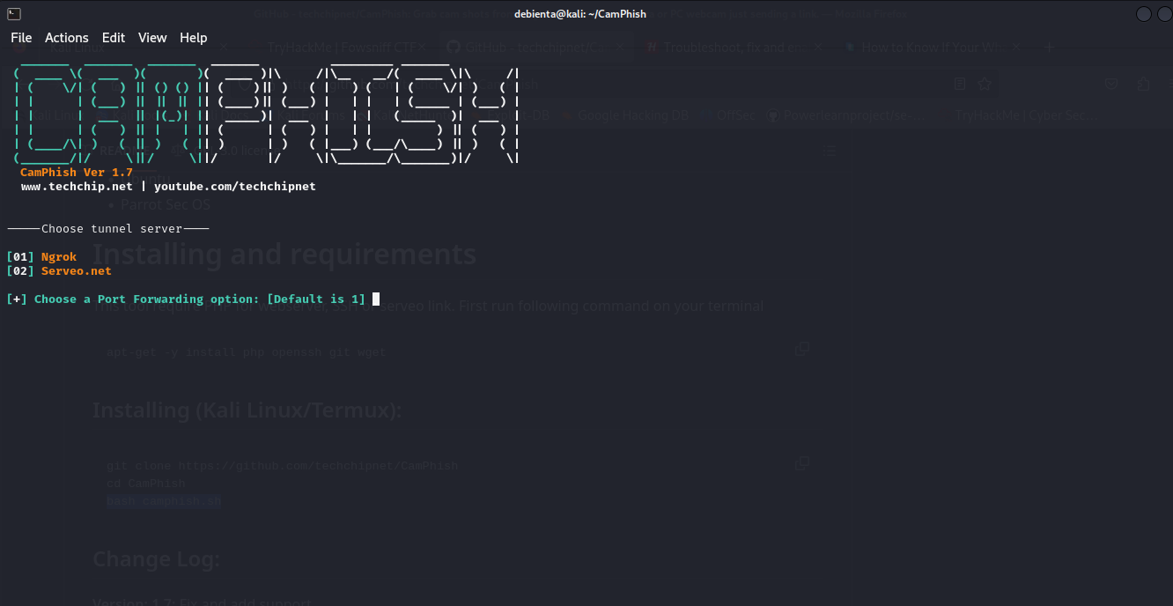
Choose your tunnel server for port forwadding; in my case I took ngrok
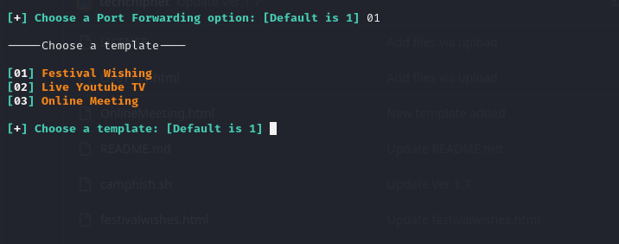
Choose a template to use from the three: In this case I chose live youtube then pasted the link to the live session.
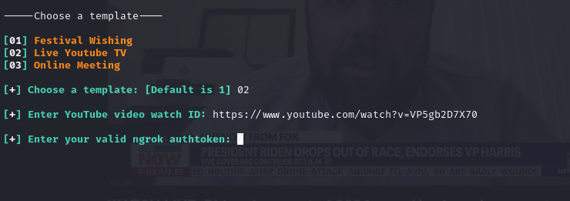
Create an account for ngrok in the website first: sign up and verify your account
After verification you will get your auth token in the dashbord
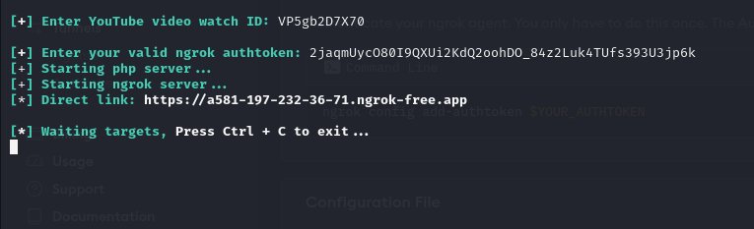
After the target opens the link you will see the folowing in your terminal

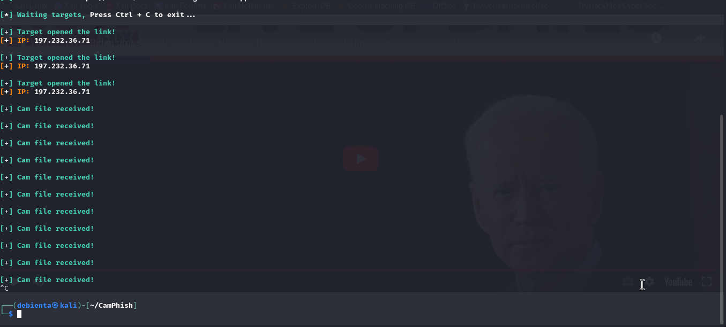
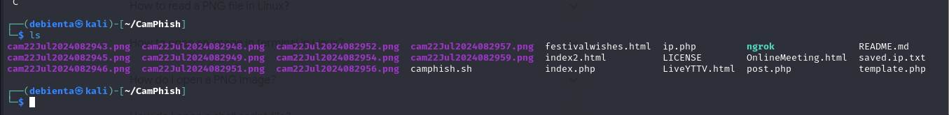
This are the saved png files from the target device
Explain effective strategies for educating and raising awareness among employees about safeguarding against such types of phishing attacks.
Providing training to employees is an important aspect of phishing prevention in organizations. Employees need to know what phishing scams look like, in order to actively prevent them.
Organizations should therefore train and educate their employees to:
- Understanding the types of phishing scams: Educate employees about different types of phishing scams, including email, text message, and phone phishing.
- Spotting the signs of a phishing email: Teach employees how to identify common indicators of a phishing email, such as urgent language, suspicious sender addresses, and requests for personal or sensitive information.
- Not clicking on links: Employees need to be extremely careful when clicking on links, whether in email communications or on the web.
- Blocking popups and ads: Employees should be instructed on how to block popups and ads, because these might contain malicious links or other threats.
- Never giving away private information: Employees should know never to divulge passwords or any sensitive information without carefully verifying the source and reason for the request.
- Safe practices for handling emails: Emphasize the importance of not opening attachments and verifying the legitimacy of emails before taking any actions. If absolutely necessary, employees should open suspicious documents in an isolated environment.
- Reporting phishing attempts: Encourage employees to report any phishing attempts they receive, so that the organization can take appropriate measures to prevent further attacks.

